Automatic Multilingual System from Speech
Suchit Agarwal¹, Akshay Chatterjee²,Ghazaala Yasmin3

1 Department of Computer Science and Engineering, St Thomas‘ College of Engineering and Technology, Kolkata 700 023, India
suchitagarwal1995@gmail.com
2 Department of Computer Science and Engineering, St Thomas‘ College of Engineering and Technology, Kolkata 7000 023, India
akshay.chatterjee2015vit@gmail.com
2 Department of Computer Science and Engineering, St Thomas‘ College of Engineering and Technology, Kolkata 7000 023, India
me.ghazaalayasmin@gmail.com
Abstract. Automatic language identification is the process by which the language of a digital speech utterance is recognized automatically by a computer. Commenced Language Identification Systems sequentially transform the speech signal into discrete units and then apply statistical methods on the resultant units to extract their language information. Today, a large number of audio retrieval features exists for automatic speech and language recognition. The proposed method has nominated an automatic system for well known multi languages. The identification has been done using a new set of audio features. The suitable feature has been adopted. This includes Zero Crossing Rate, Spectral Flux, Pitch, Mel-frequency Cepstral Coefficients, Tempo and Short Time Energy. These features have been used exclusively for identifying the language along with the help of classifiers and feature selection algorithms.
Keywords: Mel-frequency Cepstral Coefficients (MFCC), Pitch, Tempo.
1 Introduction
Communication is an elementary behavior that spans throughout the animal species. Human language is a one of a kind system, which segregates humans from the other animals. It is a process of sending and receiving information among people. The most common communication mode for humans is speech. Speech can be in varying language depending on the culture the person belongs to. Humans are the most dominating language identifiers in the domain of speech recognition. They can determine within a glimpse of second whether the language of the hearing speech is known to them. This eventuality has come true because of the basic discrimination in the sound pattern characteristics based on the frequency, time and perceptual domain. This certainty has provoked the motivation to introduce a potent scheme for the proposed plan.

Humans, as a part of their human intelligence, have the ability to differentiate between spoken languages. The quest to automate work has never stopped. Just like any other Artificial Intelligence technology, this spoken language identification work also aims to replicate the human ability to differentiate various spoken language. The proposed work includes the identification of popularly spoken languages in Asia. During the training phase, the speech messages for each language are analyzed, resulting in a model for each type of the language. During testing, a previously unknown test message is entered into the system, and the system outputs the language comparable with the model that most closely matches with the test message. It is estimated that there exist several thousands of spoken languages in the world. In this paper, we will be dealing with only a few languages. Every country in Asia has its official languages spoken in the country. We aim at providing a way to identify the languages spoken in Asia based on the speech audio.
This is done with the help of classifiers. The extracted feature vectors are fed to a classifier that based on certain rules determines the class of the incoming vector. After that, we use feature selection algorithm to narrow the feature set that yields the desired output.
1.1 Related Work
The differences in perception between speech and other sounds have been a source of interest for many authors and researchers since the ages. In the past few decades, researchers have explored many speech features. They have gone through the Survey related to Language discrimination techniques and its applications [1]-[3]. Mahadev and Lakhani [4] have initiated language classification using deep neural network from the standard feature called Mel Frequency Cepstral Coefficients (MFCC). Chandrasekhar, Sargin and Ross [5] have introduced Gaussian Mixture Models and Shifted Delta Cepstral Features for the recognition of language. Itrat, Ali et al. [6] have discriminated Pakistani languages using MFCC and vector quantization. Adami, Hermansky et.al [7] have incorporated speech segmentation for speaker as well as language recognition. Dehak, et.al [8] and Yu, et.al [9] both have proposed the Language Recognition via I-vectors. Gwon, et.al [10] have introduced a scheme for language recognition based on sparse coding. Behravan, Kinnunen and Hautamaki [11] have introduced an effective scheme of i-Vector Selection for Language Identification. Vatanen, Vayrynen and Virpioja [12] have identified different languages from Short Text Segments using N-gram Models. Torres-Carrasquillo, Reynolds and Deller [13] have proposed an approach for Language Identification where they have used gaussian mixture Model . Karpagavalli, S., and E. Chandra [14] did a detailed study on automatic speech recognition. Lartillot, Olivier, and Petri Toiviainen [15] presented the MIRtoolbox for the extraction of various audio features.
2 Proposed Methodology
Audio can be of various types, namely, speech and non-speech. Speech is an audible form of communication that humans use, that is based upon the syntactical combination of items taken from their vocabulary. The proposed work uses certain audio features to differentiate Asian languages. The features are fed to the classifier to further identify the class of the language. A basic flow chart for the system is given in Fig.1.
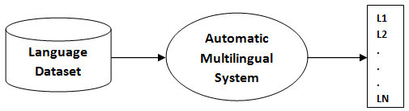

- Basic Work Flow of the system

For determining a language from an audio speech we need to first classify it. This is depicted in Fig. 2. Audio dataset has been subjected for feature extraction and then significant feature has been selected using feature selection algorithm. The selected feature has been served for classification for 28 different classes of languages in Asia.

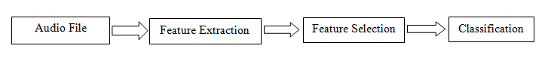

- Audio Classification Process
2.1 Feature Extraction

2.1.1 Pitch
Pitch is termed as a measure of its degree of highness or lowness. The rate of vibrations through which is it generated determines the quality of the tone. A shrill speech is with a frequency having higher pitch whereas vice versa for bass speech. This is one of the factor which changes with respect to different language. This is why we have incorporated this feature in our methodology. Here the speech signal has been broken up into 88 frequency band. Now each band has got divided into short time frame. From these frame short-time mean-square power (STMSP) has been calculated followed by the averaging the value of STMSP for each band. Fig. 3 shows the variation of the pitch with respect to the time. As well as it showing the variation of the pitch scale with respect to the energy bands.

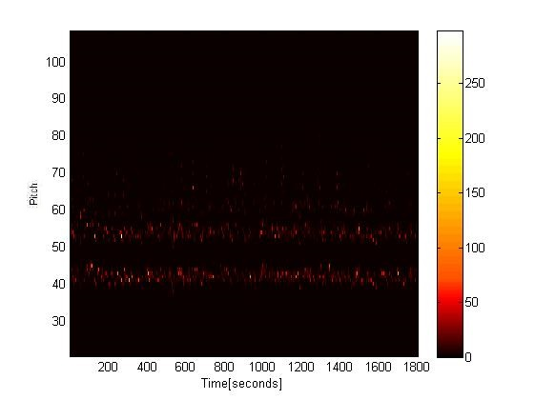
- Pitch plot of sample language file

2.1.2 Short-Time Energy (STE)
Short-Time Energy (STE) is a simple time-domain feature, which is widely used by researchers. STE is suitable for discriminating speech and music. Speech consists of words interleaved by silence which gives variation of STE which is quite different from the pattern obtained for music. The energy of the nth frame is defined in Eq. 1.
En = 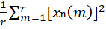 (1)

where, E_{n} denotes the nth frame energy, r is the frame length, and x_{n}[m] represents the m^{th} sample in the n^{th} frame.
2.1.3 Zero-Crossing Rate (ZCR)
The Zero-Crossing Rate (ZCR) is an extremely popular short time feature. ZCR depicts the concentration of energy in the spectrum. It can be measured as the number of times the signal crosses zero (i.e., changes sign) within the frame (Eq. 2).

ZCRn = (2)

Where, r is the number of samples in the nth frame and

sign[v] = 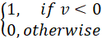 (2.a)

- Zero Crossing Rate of sample language file
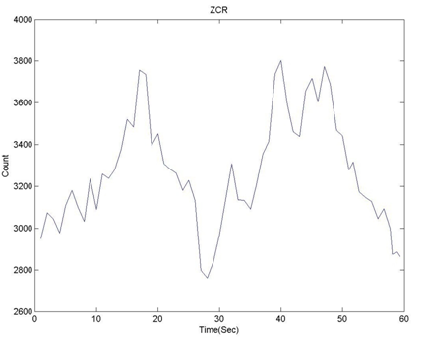

The ZCR can be viewed as a measure of the dominant frequency. Since unvoiced speech typically has significantly higher ZCR values than voiced speech, ZCR can be used to differentiate between unvoiced and voiced speech. Fig.4 shows the variation of zero crossing rate throughout the signal of a sample speech file of a any sample language.

2.1.4 Mel-Frequency Cepstral Coefficients (MFCC)

Mel-Frequency Cepstral Coefficients (MFCCs) are coefficients that altogether make up MFCC. It has been extracted from the mel-scale cepstral representation of an audio clip. The key point in MFCC is the equal spacing of the frequency bands is done on the mel-scale, which approximates the human auditory system's response more efficiently than the linearly-spaced frequency bands that are used in the normal cepstrum. Two properties of MFCCs, one being that the first coefficient is proportional to the audio energy and no correlation exists among different coefficients, this pattern made MFCCs much attractive in audio classification. Fig 5 shows the variation of a sample language speech file. The X axis is depicting the 13 coefficient and Y axis is depicting the value of the each coefficient.

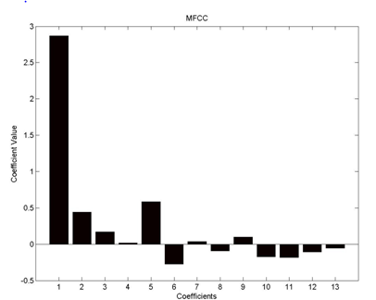

- MFCC plot of sample language file

2.1.5 Tempo
All sounds have their own speed. This speed can be measured by a property called tempo. It measures the beats per minute of the sound. It measures how the periodic occurrence of sound varies which can be used to differentiate speech from non-speech. Thus, the tempo-based feature has been picked up for the proposed feature set.

    - Spectral Flux
It is the measure of spectral change between two adjacent frames (Eq. 3). It is an important feature for the separation of music from speech. Speech alternates between periods of transition (consonant-vowel boundaries) and periods of relative stability (vowels), while other speech typically has a different constant rate of change. Fig 6 shows the plot for spectral flux for a sample language file . Here the value of the flux has been notified against the real time value in seconds. The figure shows that the flux value changes minutely with respect to the whole signal. So it must give discriminative values with respect to each language file.
SFn = 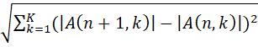 (3)

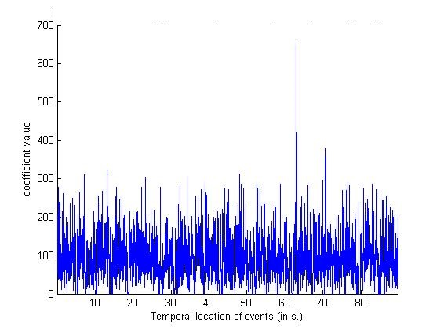
- Spectral flux of the sample language speech file

2.2 Feature Selection

Feature selection, is the process of selecting a set of relevant features in model construction. It reduces the effort of classification. Here feature selection has been achieved by reducing the dimension by incorporating a statistical tool called Principal Component Analysis PCA and Consistency based selection algorithm CFS.167 features got reduced to the final set of feature vector of dimension 21. Table.1 shows the selected feature after using feature selection algorithm. The selected feature with minimum number of attribute that is 18 has been subjected for classification. We have used weka tool [16] for feature selection algorithm

Table 1. Feature Selection Algorithm for Extracted feature

System | Attribute Evaluator | No. of selected attributes
Language Identification System | PrincipalComponents | 21
Language Identification System | Consistency based Feature Selection CFS | 18

2.3 Classification

Classification is the procedure of categorizing a given observation based on the past observation. There is a training set of data that contains observations whose classes are known. These sets are used for the testing phase. Classification is considered under the domain of supervised learning. It is an approach in which the computer program learns from the input data and then uses this to authenticate new observations. Classification models are of varying types. Here, we have used Weka Tools for the classification purpose. We have chosen 10 fold cross validation to evaluate predictive models by dividing the original sample into a training set that trains the model, and a test set that evaluates it.

2.4 Dataset Collection

The Experiment has been conducted on 600 audio files containing 31 official languages in different countries of Asia. It is very difficult to get bench mark audio data. The audio data has been collected from different sites of internet. The data contains speeches, debates and the recordings of public speakers.

3. Experimental Result

The feature selection algorithm was run on the entire feature extracted. The output of the algorithm was fed into a number of classifiers. Upon classification, we obtained an average accuracy of 81%. We were successfully able to identify 81% of the Asian languages correctly with the help of the overall system developed. Different classifiers have been audited to analyze the efficiency of the system. The accuracies have been summarized in Table 2. In Table 2 different types of classifiers has been taken into consideration. Furthermore different classifiers of different types have been considered. The result has been calculated on 10 folds cross validation. Table 2 summarizes the result of classification.

Table 2. Classification Accuracy (in %) For proposed work

Classifier Type | Classifier Name | Accuracy (%)
Bayes | Naïve Bayes | 91.76
Function | SimpleLogistics | 89.54
Function | SMD | 89.6
Lazy | IBK | 84.63
Lazy | Kstar | 91.54
Meta | Bagging | 91.15
Meta | Iterative Classifier Optimization | 81.00
Meta | Random Committer | 87.15
Meta | Randomizable Filtered Classifier | 92.77
Rules | PART | 90.31
Trees | J48 | 91.61
Trees | LMT | 89.76
Trees | RandomForest | 94.61
Trees | RandomTree | 91.69
Trees | REPTree | 91.07

3.1 Comparative Analysis

The Methodologies of the past work has been chosen for the comparison with the proposed LID system. We have done comparative study with three papers and have achieved better results with the proposed work in Table 3. Mahadev and Lakhani [4] have used the MFCC approach for the classification of language. While working on their method we achieved an accuracy of 75% whereas in our proposed feature algorithm we have attained an accuracy of 81%. Itrat, Ali et al. [6] have worked on differentiating Pakistani languages using MFCC and vector quantization. Their approach gave us an accuracy of 79%. Gwon, Youngjune L., et al. [10] have proposed the technique of sparse coding and their method gave an accuracy of 80 %.

Table 3. Comparative study (in %) for the substantial work.

Approach | Accuracy
Mahadev and Lakhani [4] | 83%
Itrat, Ali et al. [6] | 89%
Gwon, Youngjune L., et al. [10] | 85%
Proposed Method | 91%

4. Conclusion

In the propounded work, a contrasting approach towards automatic language identification has been propounded. The application of the system has been pursued to a latest problem. The approach presented will abridged the use of the classical methods while maintaining their reliability. The proposed system will be explored to another problem to analyze the performance of the system. Well known Asian languages has been successfully identified from a set of various audio inputs with an accuracy of 81%.The future work on this project includes expansion of the language set on global level based on seven continents. Furthermore dialect identification for global language will be identified.

Acknowledgments “This chapter does not contain any studies with human
participants or animals performed by any of the authors.”
References
- 1 Garg, Archana, Vishal Gupta, and Manish Jindal. "A survey of language identification techniques and applications." Journal of Emerging Technologies in Web Intelligence 6.4 (2014): 388-400.
- Karpagavalli, S., and E. Chandra. "A Review on Automatic Speech Recognition Architecture and Approaches." International Journal of Signal Processing, Image Processing and Pattern Recognition 9.4 (2016): 393-404.
- Grothe, Lena, Ernesto William De Luca, and Andreas Nürnberger. "A Comparative Study on Language Identification Methods." LREC. 2008.
- Lakhani, Vrishabh Ajay, and Rohan Mahadev. "Multi-Language Identification Using Convolutional Recurrent Neural Network." arXiv preprint arXiv: 1611.04010 (2016).
- Chandrasekhar, Vijay, Mehmet Emre Sargin, and David A. Ross. "Automatic language identification in music videos with low level audio and visual features." Acoustics, Speech and Signal Processing (ICASSP), 2011 IEEE International Conference on. IEEE, 2011.
- Itrat, Madiha, et al. "Automatic Language Identification for Languages of Pakistan." International Journal of Computer Science and Network Security (IJCSNS) 17.2
- Adami, André G., and Hynek Hermansky. "Segmentation of speech for speaker and language recognition." In Eighth European Conference on Speech Communication and Technology. 2003.
- Dehak, Najim, Pedro A. Torres-Carrasquillo, Douglas Reynolds, and Reda Dehak. "Language recognition via i-vectors and dimensionality reduction." In Twelfth annual conference of the international speech communication association. 2011.
- . Yu, Chengzhu, et al. "UTD-CRSS system for the NIST 2015 language recognition i-vector machine learning challenge." Acoustics, Speech and Signal Processing (ICASSP), 2016 IEEE International Conference on. IEEE, 2016.
- Gwon, Youngjune L., et al. "Language recognition via sparse coding." INTERSPEECH. 2016.
- Behravan, Hamid, Tomi Kinnunen, and Ville Hautamäki. "Out-of-Set i-Vector Selection for Open-set Language Identification." Odyssey 2016 (2016): 303-310.
- Vatanen, Tommi, Jaakko J. Väyrynen, and Sami Virpioja. "Language Identification of Short Text Segments with N-gram Models." LREC. 2010.
- Torres-Carrasquillo, Pedro A., Douglas A. Reynolds, and John R. Deller. "Language identification using Gaussian mixture model tokenization." Acoustics, Speech, and Signal Processing (ICASSP), 2002 IEEE International Conference on. Vol. 1. IEEE, 2002.
- Karpagavalli, S., and E. Chandra. "A Review on Automatic Speech Recognition Architecture and Approaches." International Journal of Signal Processing, Image Processing and Pattern Recognition 9.4 (2016): 393-404.
- Lartillot, Olivier, and Petri Toiviainen. "A Matlab toolbox for musical feature extraction from audio." International conference on digital audio effects. 2007.
- Hall, Mark, et al. "The WEKA data mining software: an update." ACM SIGKDD explorations newsletter 11.1 (2009): 10-18.

